

Minutes of a Meeting of Stoke by Clare Parish Council
held at 7.30pm on Wednesday 24th January 2024 at
The Barn, Ashen Lane, Stoke by Clare

Present
Parish Councillors:
G Dadd (Chairman) | K Nichols
J Blake James | E Smith
J Kiddy | P Vincent
R McKenny
Also present:
Councillor K Richardson | West Suffolk Council
Councillor M Rushbrook | West Suffolk Council
Judith Dignum | Parish Clerk and Responsible Financial Officer
Apologies for absence: Councillor N Clarke (West Suffolk Council)

- Chairman’s Welcome and Apologies for Absence
The Chairman welcomed those present and apologies for absence were received.

Death of Former County Councillor Mary Evans
With sadness, the Chairman informed the Council of the recent death of Mary Evans, who had represented Stoke by Clare as County Councillor for the Clare electoral division from 2013 until she stood down in 2021. Members paid tribute to Mary’s dedicated public service and observed a minute’s silence in her memory. Condolences were expressed to her husband, family and friends.

Suspension of Standing Orders (7.34pm)

Upon the motion of the Chairman, duly carried, Standing Orders were suspended to allow public questions and the receipt of reports.

- Receipt of Reports and Consideration of Issues Raised by Members of the Public
The Council received with thanks written updates from County Councillor Bobby Bennett and District Councillors Nick Clarke, Karen Richardson and Marion Rushbrook.

Members were pleased to note the creation of West Suffolk Council’s Capital Sports Fund. It was agreed to alert village sports clubs to this new opportunity to apply for a council grant to help increase participation and further enhance activity.

Noting that dog fouling continued to cause a nuisance in Stoke, Cllr Richardson advised that additional signage was available to download from the West Suffolk Council website. Had suitable evidence been obtained, the owner of any dog responsible for fouling could be reported via the Council’s reporting tool, with a potential fine of £1,000.

The Chairman, on behalf of the Council, expressed thanks to Cllrs Clarke, Richardson and Rushbrook for making funds of £600 available from their Locality Budgets towards the cost of a new Parish noticeboard.

Standing Orders re-applied (7.40pm)

- Declarations of Interest
Cllr Roger McKenny declared an interest in Agenda Item 5ii (Grant Application – Stoke by Clare Parish Church) in that he is the Church Warden. In accordance with the Code of Conduct adopted by the Council, Cllr McKenny took no part in the voting on this matter. Minute 5ii below refers.

- Minutes: 13 December 2023
Upon the motion of Cllr Kiddy, seconded by Cllr Nichols and duly carried, it was:

Resolved:
That the minutes of the Parish Council meeting held on 13 December 2023 be approved as a correct record and signed by the Chairman.

The following matters arose from consideration of the minutes:

- Minute 2 (Receipt of Reports and Consideration of Issues Raised by Members of the Public)
Cllr Smith updated the Council on the current position regarding the condition of the bridge at Boyton End / Baythorne End. Although some jetting work had been carried out since the last meeting, this had not tackled the underlying issue of the bridge’s structural integrity and there were now concerns that it could soon become impassable. The Clerk was asked to liaise with Essex County Council as the authority beleived to be responsible for the bridge.

Cllr McKenny updated the Council on the current position regarding the repaired village sign, noting that the new roof was still awaited.

- Minute 4 (Minutes: 19 October 2023)
Cllr Kiddy updated the Council on progress regarding the planned repair/renewal of the War Memorial, explaining that she had liaised with a neighbouring parish who had recently completed a similar project. She undertook to investigate the possibility of obtaining a grant towards the cost of the work.

- Minutes 8 (Club and Society Minutes, including the Bowls Club AGM)
Noting the generous contribution from the District Councillors towards the cost of a new notice board (minute 2 above refers), it was agreed to purchase a board from the company which had supplied the board at the village shop, at an anticipated cost in the region of £1,750. The Board would be installed on the grass area at the entrance to Church Park.

Variation in the Order of Business
It was agreed to vary the order of the agenda such that Item 6 (Renewal of Grounds Maintenance Contract) be considered immediately before Item 5ii (Grant Application: Stoke by Clare Parish Church). This was to enable those items to be considered in advance of the Budget and Precept 2024/25.

For ease of reference, the items are recorded in the order in which they appeared on the agenda.

- Finance and Audit
The Cashbook was available for inspection.

- Financial Overview as at the Third Quarter Stage
The Council received a report by the Responsible Financial Officer setting out the forecast financial position of the Council as at the third quarter of the 2023/24 financial year.

In response to concerns about the wording of a comment in paragraph 4.2 relating to expenditure levels, it was agreed to amend the text to reduce the possibility of misunderstanding.

The report was noted.

- Grant Application: Stoke by Clare Parish Church
Cllr Roger McKeny declared an interest in this item (minute 3 above refers).

A decision on this issue had been deferred from the previous meeting.

The Council considered a report deferred from the previous meeting, concerning an application from the Parochial Church Council (PCC) of Stoke by Clare for a grant towards the 2024 insurance costs for the church. The report had been updated to set out the latest position regarding a council’s ability to provide financial support to a church through its powers under S137 of the Local Government Act, 1972.

The Council considered the application in detail, noting that a grant of £1,500 had been awarded in four of the five previous years. Members expressed support for the Church as a valuable community asset, beyond its role as a place of worship. However, the rise in ongoing costs for the Council meant that the budget was tight, leading to an increase in the precept which may put pressure on parish residents. Were this situation to continue, it would be necessary for the Council to review its discretionary financial commitments for future years.

Upon the proposal of Cllr Edwin Smith, seconded by Cllr Justin Blake James, put to the vote and duly carried, it was:

Resolved

That a grant of £1,500 be awarded to the Parochial Church Council (PCC) of Stoke by Clare for the financial year 2024/25, to be funded through the Council’s powers under S137 of the Local Government Act, 1972.

- Budget and Precept 2024/25
The Council considered and agreed the Budget and Precept for the Financial year 2024/25, based on the recommendations of the Finance Committee (reported to the December 2023 meeting) and confirmed sums arising from consideration of the matters recorded at minutes 5iii above and 6 below.

The Council agreed that it would not be prudent to reduce the level of the precept by offsetting against forecast income for the year concerned.

Upon the proposal of Cllr Edwin Smith, seconded by Cllr Justin Blake James, put to the vote and duly carried, it was:

Resolved:

- To adopt the budget for 2024/25 as set out in Appendix 1 to these minutes.

- To set the level of the Parish Precept for 2024/25 at £23,648 (£105.74 for a Band D property), representing an increase of £21.54 per annum (25.58%) on the sum levied in 2023/24, as set out in the Precept Application attached as Appendix 2 to these minutes.

- Annual Governance and Accountability Return (AGAR)
The Clerk updated the Council on the latest position regarding the Annual Governance and Accountability Return (AGAR). Members requested clarification on additional queries which had been received from the external auditor.

- Bank Reconciliation
The Bank Reconciliation for the period 1 - 31 December inclusive (date of the latest bank statement), indicating a net bank balance of £25,615.10, was noted by the Council and signed by Cllr Dadd as Chairman of the Finance Committee: Cllr Dadd also signed the associated bank statement.

- Accounts for Payment
Accounts for payment in the sum of £1,321.96 were authorised (as set out in Appendix 3 to these minutes), and cheques signed accordingly.

Arising from discussion, the Council requested that an item on arranging refresher training for use of the defibrillator be included on the agenda for the next meeting.

- Renewal of Grounds Maintenance Contract
The Council considered quotations from three suppliers for the provision of grounds maintenance services to the Council in 2024/25.

Members considered the options in detail, aiming for an appropriate balance between price and quality. Although the quote from the current contractor represented the best price, general concern was expressed regarding the quality of the service over the past year. Councillors noted that, following a recent review of the service, the supplier had given a commitment to planned improvements.

The Council opted to renew the contract with the current supplier on the grounds of cost and the positive relationship which had developed. However, there was a clear expectation of value for money and a visible improvement to the service provided. The Council would monitor closely the work being carried out to ensure this was consistent with the contract and would request remedial action at no charge if necessary. Should the service continue to fall below the required standard, the Council would be unlikely to renew the contract in future. Cllr Dadd undertook to meet with the supplier to explain the Council’s position and discuss concerns around the football field and the type of equipment used for the Village Green.

Upon the proposal of Cllr Edwin Smith, seconded by Cllr Justin Blake James, put to the vote and duly carried, it was:

Resolved

That the quotation received from West Suffolk Council to provide grounds maintenance services for the Parish Council in 2024/25 be accepted in the sum of ££6,673.31 plus VAT.

- Repairs to The Barn Boundary Fence
The Council considered a request from a resident for a contribution towards the cost of repairing a damaged fence adjacent to the boundary between The Barn and a private property. It was agreed to defer a decision pending liaison between the Chairman and the resident concerned.

- Community Facebook Page Policy
Deferred until the next meeting of the Council.

- Correspondence

The Record – 40th Year Edition: The Council congratulated the Team responsible for producing The Record, now approaching the occasion of its 40th edition. Cllr Jane Kiddy undertook to prepare and submit a contribution on behalf of the Parish Council.

- Dates of Future Meetings

Noted:

That meetings of the Council in 2024 will take place as set out below:

2024
20 March | 11 September
22 May (APM/APCM) | 23 October
19 June | 11 December
24 July

Unless otherwise notified, all meetings are open to the public and will take place at The Barn, Ashen Lane, Stoke by Clare, CO10 8JA, on Wednesday evenings commencing at 7.30pm.

- Urgent Business
None.

The meeting closed at 9.00pm.

Signed………….……………………………………………….

Chairman
20 March 2024
Appendix 1
Stoke by Clare Parish Council
Budget 2024-25
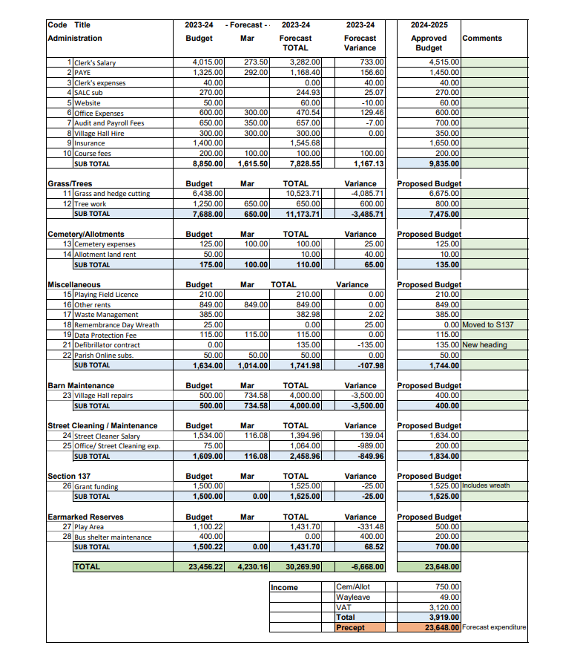

Appendix 2
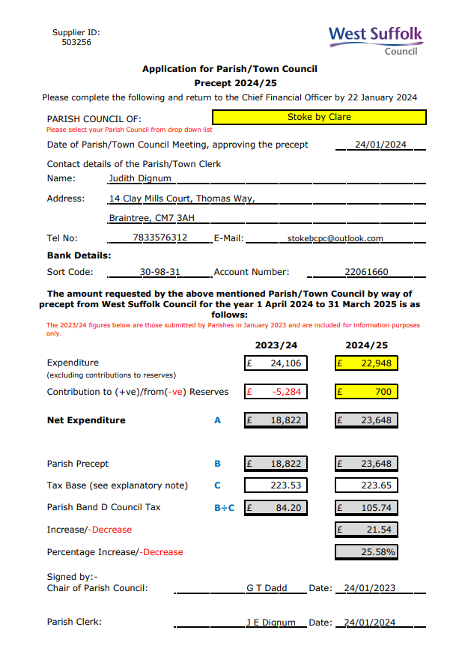

Appendix 3

Stoke by Clare Parish Council
Accounts for Payment Authorisation, 24 January 2024

AUTHORISED
 | Cheque No | To Whom | Amount  £ | Authorised
 | 616 | Street Cleaner salary Dec 2023 /Jan 2024 | 232.56 | 24/01/24
 | 617 | Parish Clerk salary Dec 2023 /Jan 2024 | 547.00 | “
 | 618 | HMRC (Employers NI, Q3) | 292.40 | “
 | 619 | Village Hall Cttee – room bookings | 250.00 | “
 |  | TOTAL | £1321.96

